**A crm application to manage the services offered by an institution**

**Team name : Nan mudhalvan id:**

Vaishali B : CD5EBF30C257C40B0B54FDF2EC96BE59

Thamizhselvi G C : BBE9070057025DE88984663CF56881C4

Rajeswari M : EE160A518988AE185044BB980A854867

Varalakshmi V : 7F6FA2CD8B39D7D9D134B078BE326380

## Project Overview:

## This project is focused on developing a **CRM Application for Service Management**, designed to address the primary challenge of inefficient service tracking and customer relationship management within the institution. The goal is to deliver a comprehensive solution by leveraging the **Salesforce platform** and its suite of CRM tools, including automation workflows, real-time dashboards, and customer-centric data management. Through this project, we aim to enhance **operational efficiency, user engagement, and data-driven decision-making** and support the long-term goals of the institution in providing exceptional service quality and fostering stronger customer relationships.

# Objectives:

**Business Goals:**

* Improve service management processes by automating workflows and reducing manual effort.
* Enhance customer satisfaction through timely communication and personalized services.
* Enable data-driven decision-making by providing actionable insights via real-time dashboards and reports.

**Specific Outcomes:**

* **Centralized Customer Data:** Create a single source of truth for all customer-related information, including profiles, service history, and feedback.
* **Service Tracking and Automation:** Implement tools for tracking services from initiation to completion, with automated notifications and escalations.
* **Analytics and Reporting:** Deliver interactive dashboards and reports to monitor service performance and identify trends.
* **User Training and Adoption:** Ensure users are proficient in using the Salesforce platform through comprehensive training programs and support.
* **Integration with Existing Systems:** Seamlessly connect Salesforce with other organizational tools, such as payment systems or legacy databases, for a unified workflow.

# Salesforce Key Features and Concepts Utilized:

* **Custom Objects and Fields:**
  + Designed custom objects for managing services, clients, and feedback, tailored to the institution’s unique requirements.
  + Configured custom fields to capture essential data, such as service priority, status, and customer preferences.
* **Automation Tools:**
  + **Flow Builder:** Implemented complex workflows, such as multi-step approval processes and automated task assignments.
  + **Process Builder:** Streamlined repetitive processes like sending notifications, updating records, and triggering actions based on specific conditions.
  + **Workflow Rules:** Created rules for automating simple processes, such as setting field values or sending email alerts.
* **Reports and Dashboards:**
  + Built dynamic, real-time dashboards to visualize key performance indicators (KPIs), such as service response time and customer satisfaction scores.
  + Generated customized reports for trend analysis and decision-making, including service performance and feedback analysis.
* **Customer 360:**
  + Leveraged Salesforce’s unified customer view to provide a holistic understanding of each client, including their service history, preferences, and interactions.
* **Service Cloud Features:**
  + Utilized **Case Management** for tracking customer issues from creation to resolution.
  + Enabled **Knowledge Base** to empower users with self-service capabilities and reduce service resolution time.
* **Email Integration:**
  + Configured Salesforce Email Templates for consistent communication with customers.
  + Integrated email services for seamless tracking of customer interactions within Salesforce.
* **Data Import and Management:**
  + Used **Data Loader** to migrate legacy data into Salesforce.
  + Enabled automated data validation to ensure the accuracy and consistency of records.
* **Security and Access Control:**
  + Implemented **Role Hierarchies** and **Sharing Rules** to enforce data security and control access based on user roles.
  + Configured **Profiles and Permission Sets** to provide granular access control for different user groups.
* **AppExchange Integrations:**
  + Integrated third-party apps from Salesforce AppExchange to extend CRM functionalities, such as survey tools or payment gateways.
* **Mobile Access:**
* Enabled the Salesforce Mobile App for on-the-go access, allowing staff to view and update records anytime, anywhere.
* **Chatter for Collaboration:**
* Incorporated Salesforce Chatter to facilitate internal communication and collaboration among team members.
* **API and External System Integration:**
  + Utilized Salesforce APIs to integrate with external systems, such as financial software or legacy databases, ensuring seamless data exchange.

# 4.Detailed Steps to Solution Design:

1. **Create object from spreadsheet:**

* Create the course object, remaining object and relationship among the object then configure the case object and create a lightning app.

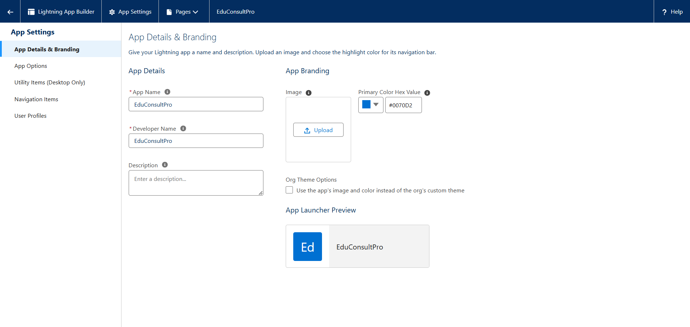

1. **Create a ScreenFlow for Student Admission Application Process:**

* Add screen element then create student record using create element and add screen element and decision element and GET record element and create registration record using create records element and create Email text template variables for email body and subject and the add an action element and screen element.

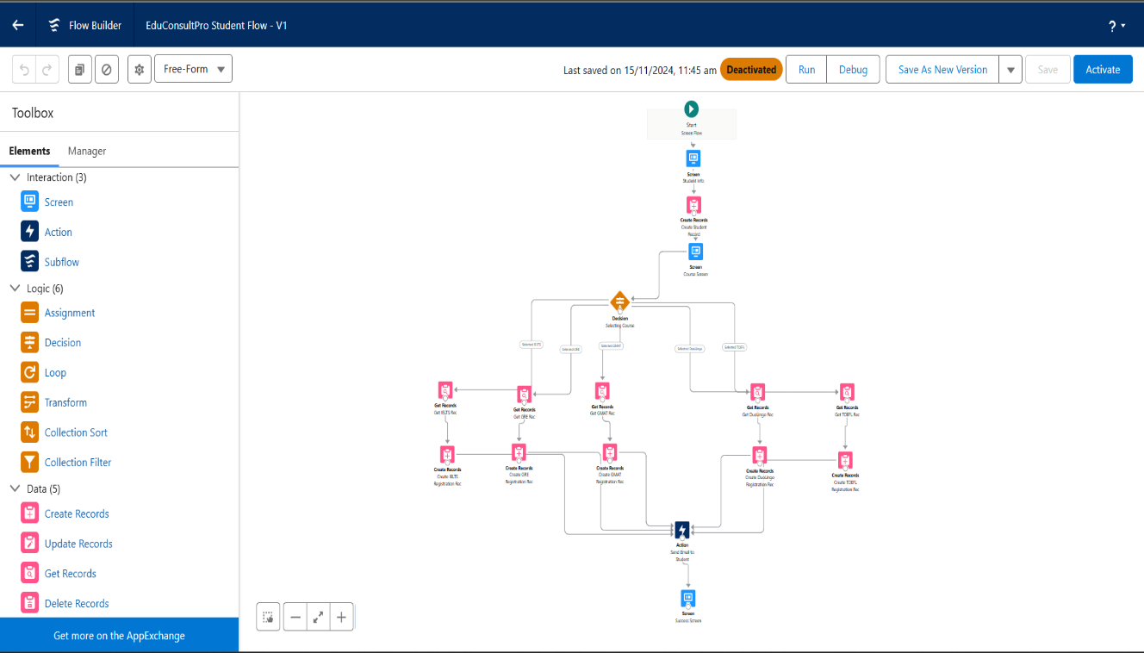

# 

1. **Create users**

# Create a user with a Standard platform user profile and configure the user settings.

1. **Create an Approval Process for Property Object:**

* Create an Email template and Approval process.

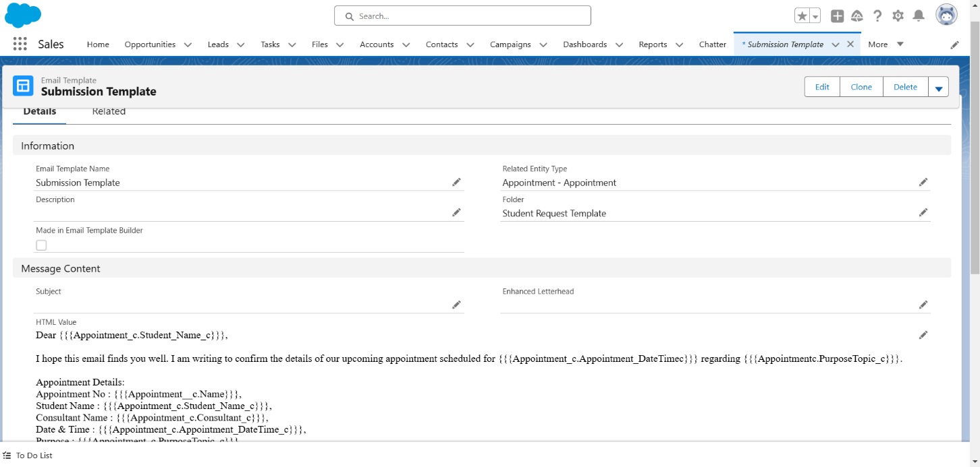 **SUBMISSION TEMPLATE**

# APPROVAL TEMPLATE

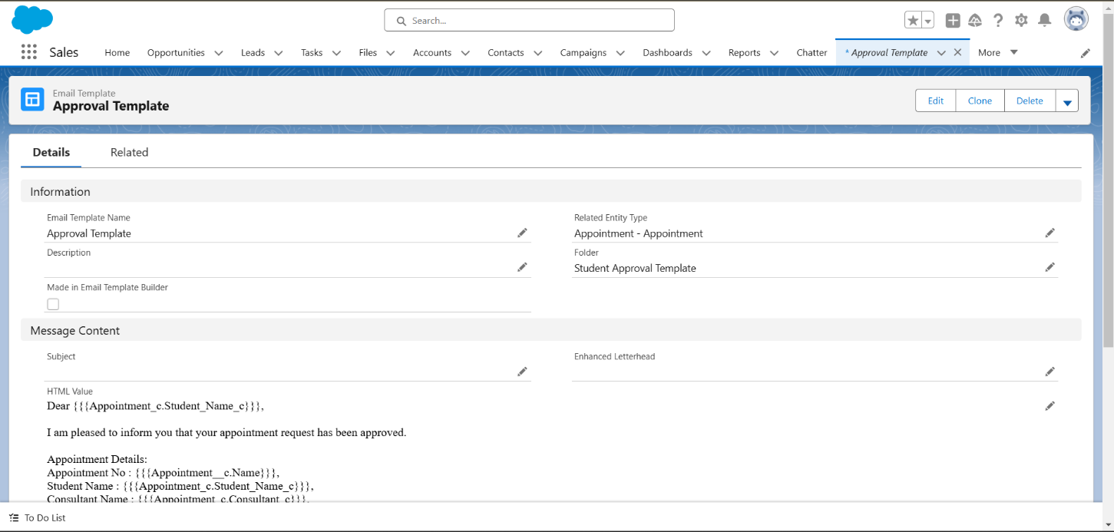

**REJECTION TEMPLATE**

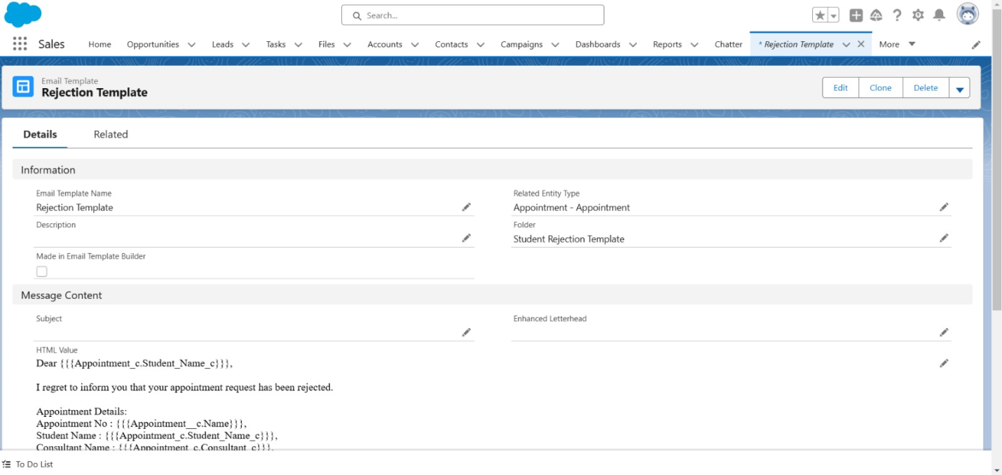

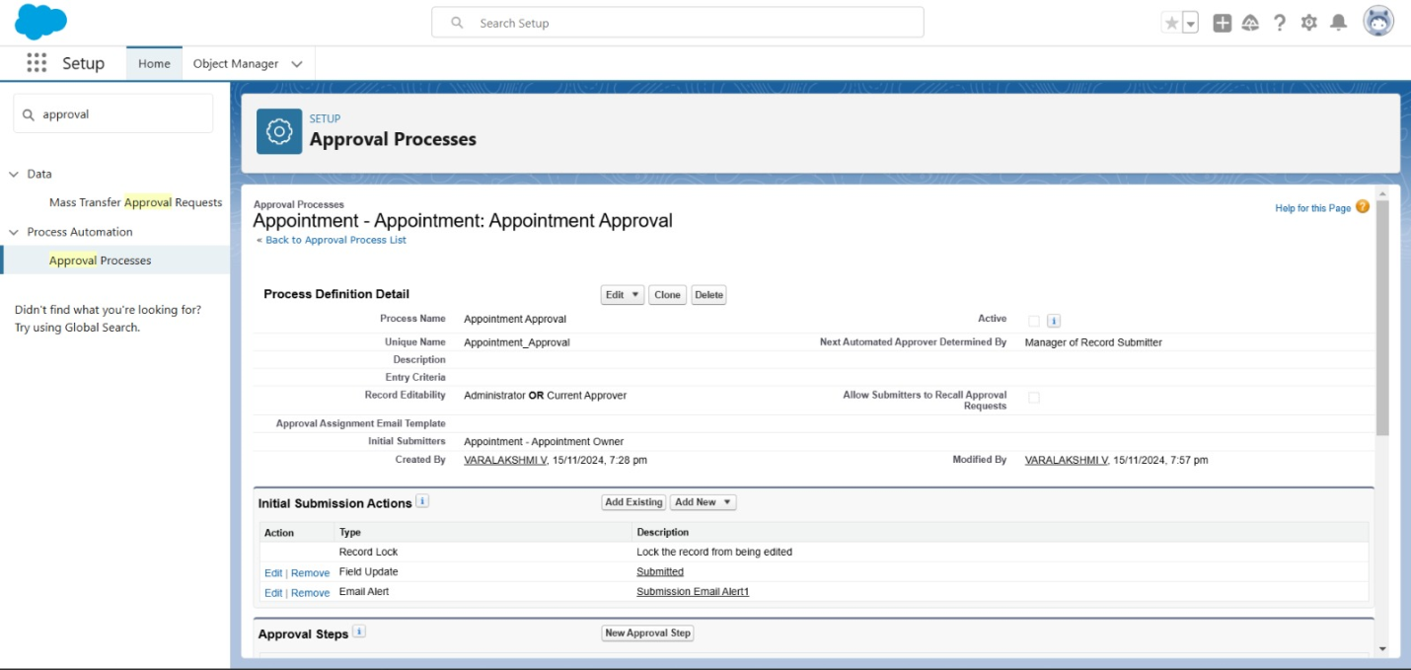 **APPROVAL PROCESS**

1. **Create a record triggered flow:**

* Configure the start element and add an action element.

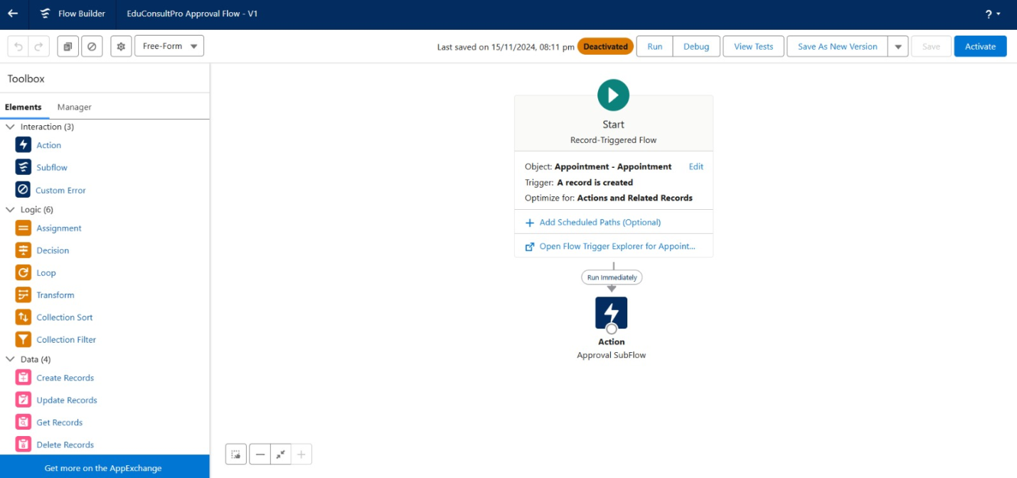

1. **Create a screeflow for existing student to book an appointment**

* Add screen element, GET record element, screen element , decision element, screen element, GET record element.
* 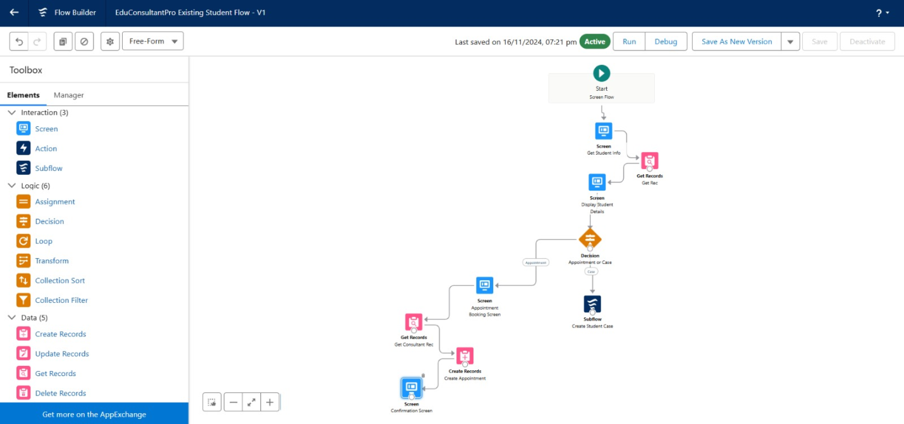Create appointment record using create records element and add screen element and an subflow element.

1. **Create a screenflow to combine all the flows at one place**

* Add screen element and again add the screen element and decision element and an subflow element and again add the suubflow element.

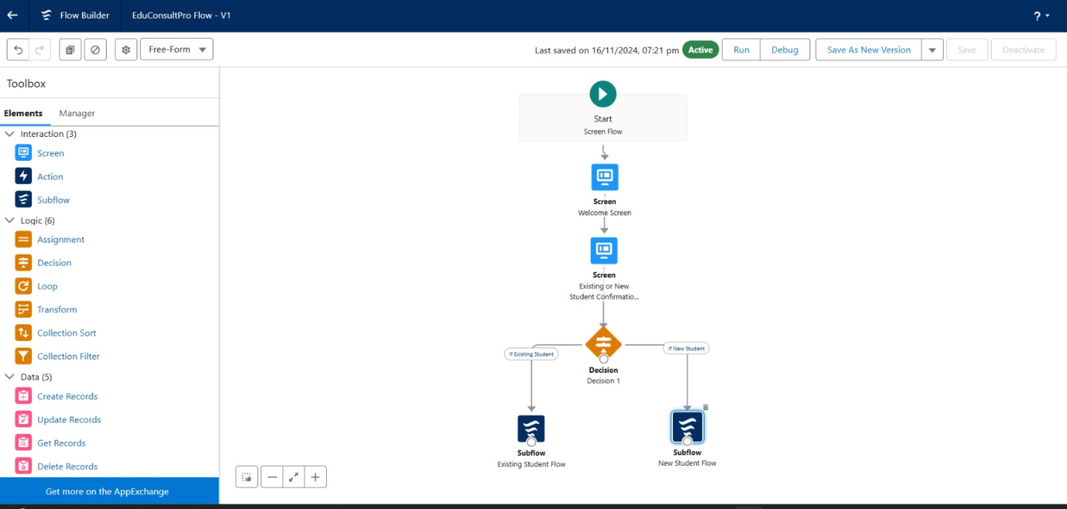

1. **Create a LIGHTNING APP page:**

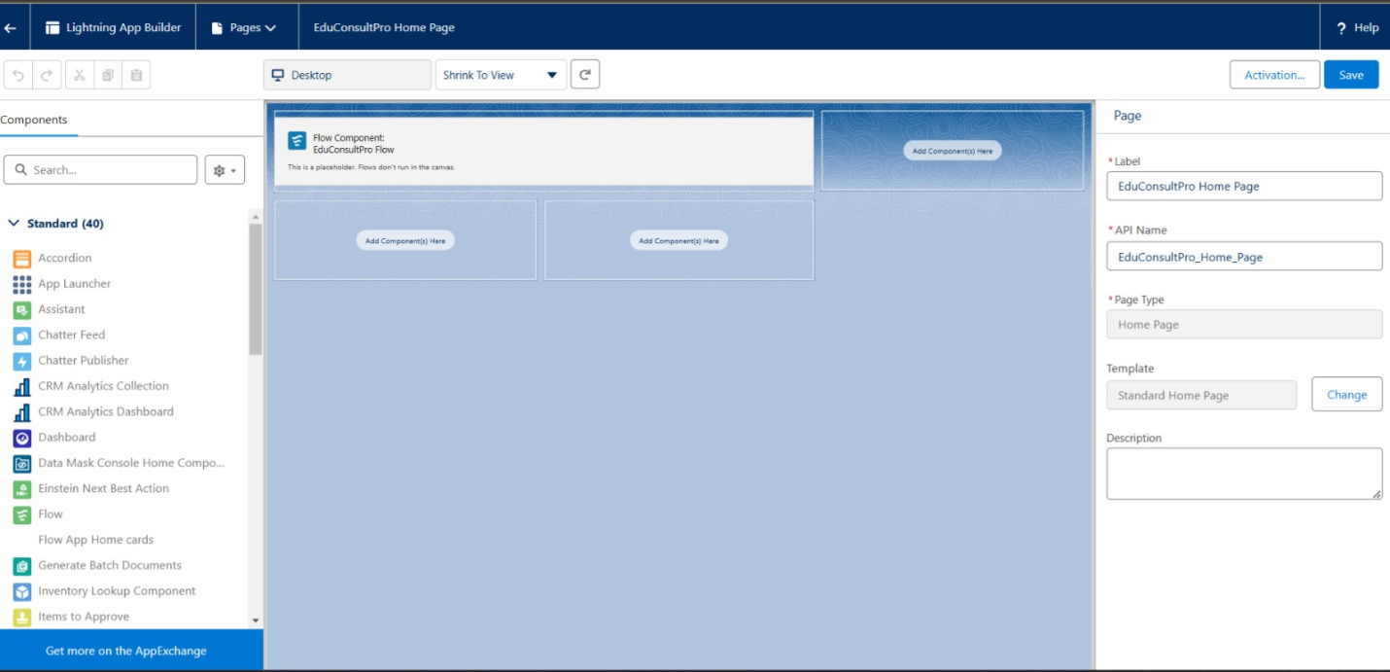

**4.Key Scenarios Addressed by Salesforce in the Implementation Project:**

#### **Service Request Management:**

**Scenario:** A client submits a request for a service through the institution’s portal or via phone.  
 **Solution:**

* Salesforce captures the service request as a Case in the Service Cloud.
* Automatically assigns the Case to the appropriate staff based on predefined criteria, such as service type or region, using **Assignment Rules**.
* Tracks the request lifecycle from submission to resolution, with status updates at each stage.

#### **Customer Communication and Engagement:**

**Scenario:** Keeping customers informed about their service status.  
 **Solution:**

* Sends automated email or SMS notifications to customers when their service request status changes (e.g., “In Progress,” “Completed”) using **Email Templates** and **Automation Tools**.
* Enables customer feedback collection through follow-up emails and feedback forms integrated with Salesforce.

#### **Escalation Management:**

**Scenario:** A high-priority service request remains unresolved for more than the acceptable time limit.  
 **Solution:**

* Salesforce triggers an escalation process using **Workflow Rules** or **Flow Builder**, notifying managers and reassigning the task to a senior staff member.
* Tracks all escalations in a dedicated dashboard for performance analysis.

#### **Client Management:**

**Scenario:** An institution representative wants to access a client’s complete history for personalized interactions.  
 **Solution:**

* The **Customer 360** feature consolidates all client information, including contact details, service history, and past feedback, into a unified view.
* Allows representatives to update client details directly from the system, ensuring the latest information is always available.

#### **Staff Training and Onboarding:**

**Scenario:** New staff members need to get up to speed with service management processes.  
 **Solution:**

* Salesforce provides an intuitive interface, with in-app guidance using **Salesforce In-App Help** and **Trailhead** modules for self-paced learning.
* Tracks training progress and generates reports on user adoption and performance.

# 6.Conclusion:

* The Salesforce CRM implementation project has successfully transformed the institution’s service management and customer engagement processes. By automating workflows, such as service request handling and escalations, the project significantly reduced manual effort, ensuring faster and more accurate resolutions.
* Dynamic dashboards and reporting tools provided real-time insights into operational performance, helping the institution identify trends and optimize resource allocation. This enhanced decision-making and ensured timely delivery of services.
* The centralized system improved customer engagement by enabling personalized communication and updates, fostering better client relationships. The integration of feedback mechanisms also allowed for continuous service improvements based on customer inputs.
* Staff productivity increased with features like task automation, role-based assignments, and mobile accessibility, ensuring seamless collaboration even in remote settings. Training and onboarding were simplified using Salesforce’s in-app guidance and self-paced learning modules.
* The project addressed compliance and data security requirements by implementing robust role hierarchies, sharing rules, and audit trails. This ensured sensitive customer information was protected while maintaining transparency for audits.
* Scalability was a key focus, ensuring the solution can adapt to future needs and integrate with additional systems as the institution grows. Overall, this project successfully met its objectives, creating a foundation for enhanced operational efficiency, improved user experience, and long-term growth.